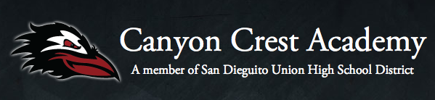

Principal's Message

Happy New Year, Ravens!
I trust that everyone had a safe and restful Winter Break with family and friends. As many of you know, we have hit the new year running at Canyon Crest and are already celebrating student performances on the field, stage, studios, and laboratories across campus.
Many of our Prop AA projects are on target for completion this Spring, and our staff and students are anxiously awaiting our new stadium, baseball/softball fields, and technology infrastructure upgrades that will strengthen internet connectivity across campus.
Our students are actively planning upcoming events and experiences for our school community this Spring. Our Slate Club is hosting our annual ‘No Place for Hate’ week that promises to offer activities designed to explore issues of tolerance and diversity. Our PALs program is currently planning our first ever ‘We Are CCA’ week, where our student body will celebrate the inclusive culture at Canyon Crest and revisit themes introduced during Raven Wellness Day (community, balance, leadership, and student connectedness).
The next time you are on campus, we encourage you to view our newest art installation (designed and created by students, funded by the Foundation) on the C Building Wall. Information regarding our Spring Enrichment Course offerings will be available in early February.
On behalf of the staff and students at CCA, we would like to thank our generous Foundation and parent community for your unwavering support and commitment to enrich the experience of every student, every day.
Go Ravens!
Karl Mueller

