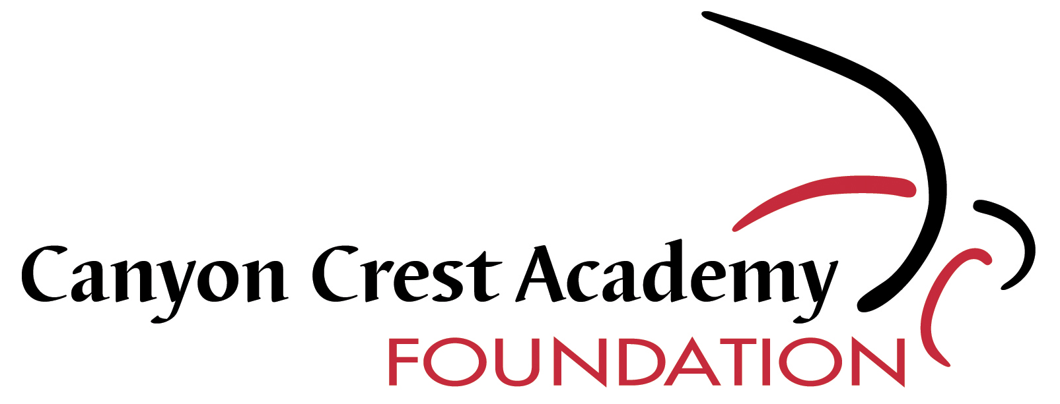

Message from the President
CCA Foundation

Happy New Year, CCA families!

December was an exceptional month for the CCA Foundation! In addition to receiving a large, multi-generation donation of $30,000 for a designated special project by way of the Wayne and Trent Seltzer families, we met our “Catch the Wave” $50,000 Raven’s Challenge fundraising goal and achieved the following impressive metrics: substantially increased our number of donors, doubled our revenue as compared to December 2013 and increased our average donation size. I would like to thank all of our donors for the generous contributions!
That said, if you have not yet contributed to the Raven’s Fund, we still need your participation! The Raven’s Fund covers non designated contributions and pays expenses such as technology improvements including new Chromebooks, 3-D printers, computers, software, enrichment classes and other general educational expenses not typically covered by District spending. There are still sports teams, Envision programs and classes, QUEST teams and classes and general academic needs that need to be funded, so if you have not yet made a donation to the CCA Foundation, please consider making a donation today!
Thus far, the new year has presented many exceptional opportunities. In addition to the Seltzer family December donation, in January, over $10,000 was raised at an Envision Theater Fundraiser. Hosts Trish and Ralph Faison generously opened their beautiful home in Rancho Santa Fe and Nancy and Drake Coker planned a spectacular event, similar to the Paris Salons from the past. Five amazing performers sang Andrew Lloyd Weber pieces from Evita, Cats and Phantom of the Opera. What an amazing evening! Kudos to our many generous families who have made these opportunities possible. If you are interested in organizing or hosting a fundraising party, please let us know! The Seltzer family has encouraged us to make their donation public in the hopes of encouraging other families to invest in their passion, and I encourage you and your families to do the same.
Amy Caterina
President
CCA Foundation

