Nutcracker 2014 T-Shirts!
Pre-Order ONLY!
Place your order by November 14

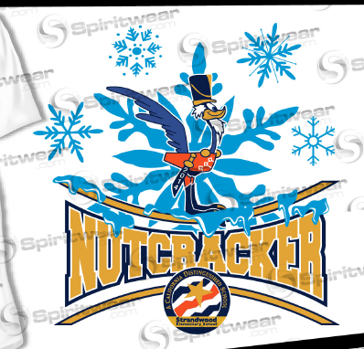

Size | YS | YM | YL | YXL | AS | AM | AL | AXL | A2XL
QTY
Only $15 each. Please make checks payable to Strandwood PTA.

Total Shirts Ordered ______ X $15 = _______________

Your Name:___________________________ email: _______________________________

Name of the Child you would like shirts delivered to: _____________________________ Room ____________

Please leave your order form with your check in the PTA drop box in the office. These T-shirts will only be offered through this pre-order special.

