Finally, a Definition of Brand You Can Actually Use

Branding is the most misunderstood subject in marketing, and there’s a reason for that: Very few people understand it enough to explain it.
That’s not because they aren’t smart; many marketers and entrepreneurs are smart. It’s because branding is deep and scary and smart people are better than anyone at avoiding deep and scary.
But we never avoid deep and scary. Not you and I. We only ever know we’re doing good work when that work is deep and scary.
So let’s go where most people are afraid to go.
Let’s start with why you would want to know the definition of a brand: Because you want to make one, and you can’t make something you can’t define, unless you want to make an accident, which is not what we aspire to do in business.
The most popular definitions of a brand that you’ll find in books, forums, and among marketers are: a brand is a company’s or person’s “essence”, or “DNA”, or “promise”. Browse LinkedIn or Quora and you’ll find these definitions in abundance.
The problem with these definitions–the reason why so many entrepreneurs like yourself have a hard time figuring out how to create a good brand–is that you can’t use those definitions. They sound profound and impressive, but you can’t implement them.
They’re empty.

Let’s say a brand is a company’s essence. That means that, to build a better brand for your company, it must have more essence.
Ok, but how do you make essence? How do you make more essence to make a better brand?
Marriam-Webster’s dictionary defines essence this way: “The intrinsic nature or indispensable quality of something, esp. something abstract, that determines its character.”
Hmm. How do you make “indispensable quality”? Or “something abstract”? What are the steps? What is the process?
No one has told you because no one can tell you. They call it “essence” because their understanding of branding is abstract. Unformed. Unclear.
And that isn’t very useful for someone building a business that won’t profit by being abstract, unformed, and unclear.
That’s why this sort of definition is bogus: they can’t be used. Many people believe that by recognizing that successful brands like Starbucks and Apple have an essence or soul (which they do) they understand what it takes to make a brand like Starbucks or Apple.
But that’s the same as saying that because you recognize that water is wet, you know how to make water: you make wet.
But that makes no sense.

Thinking of a brand as “DNA” is equally as futile. What is DNA to a brand? DNA, in science, is the code that carries the genetic information of a species across generations. But what is the genetic information of a brand? How do you make more genetic information to make more brand? Is any and all genetic information good for making a good brand so long as you have enough of it?
That can’t be: More paint does not make more painting.
Ask someone to define “brand DNA” and you will be told that it’s the brand’s essence. Ask them what the essence is and they will you it’s the brand’s soul. That’s when you need to sigh and find better help.
Let’s look at one more popular definition for a brand and then I’m going to give you the last definition of a brand that you will ever need. It’s the one you will use to make a brand you can stomp around your market with.
One of the most cited definitions of a brand is that it is a promise. It’s better than essence or DNA, but it, too, leaves many entrepreneurs weeping. That’s because it has a serious flaw. Here’s why.
On the surface, “More promise makes more brand” stands up; the more intensely you promise, the stronger your brand becomes because the more intensely you promise the more people will believe whatever it is you are promising and be compelled to pay attention to, and to buy, what you promise to give them.
Fine.
But try to make a brand out of that and you’ll be heartbroken. Here’s why: There’s only one kind of promise that people will pay for, and no one tells you what that kind of promise is (because they don’t know), which is why 80% of new businesses fail within 18 months.
Promising that your new lawn mower will cut grass will kill your business. Promising that your electrician service is honest will kill your business. Your lawn mower is supposed to cut grass and electricians are supposed to be honest; who cares?
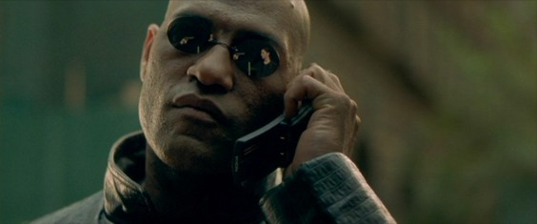
You may think those kinds of promises are so dumb that businesses wouldn’t actually use them. But they do–80% of the time. Consider this: Nokia, the once-invincible mobile phone company, whose phones were so cool they were featured in the Matrix movies, is almost unknown to anyone under 25 years old, and anyone over 25 years old remembers once having one but doesn’t want one now. What is Nokia’s promise? To “connect people”. It’s slogan is “Connecting People”.
That’s right, a mobile phone company promises to connect people. Wow, so very impressive.
And they wonder why people don’t buy their phones.
You might say Well, duh, what you need to promise is something that makes you different so that people will pay attention to your brand.
Ok. But more different doesn’t make more brand. Novelties are different, but making your company more novel does not make you more brand.
The key to a brand’s success is not that it makes a promise, but that it promises the one thing people care for you to promise. Pay attention, because here comes the big insight.
The one thing that people care for your brand to promise is this: A better world than the one they already live in.
The one thing that people want your brand to promise is this: A better world than the one they already live in.
In fact, it has to be a better world than the one your brand can actually deliver today–because if you could, you would, and you would have to sell something even better.

Consider Patagonia, the high-priced outdoor outfitter. A jacket from Patagonia can cost you $800.00. People pay it. Why? Because Patagonia believes in a world in which people live in harmony with nature by exploring it and also not impacting it: all of its clothes are sustainably sourced and made.
Who pays that $800.00? People who believe in a world in which people live in harmony with nature by exploring and also not impacting it.
This world does not exist today. That’s why Patagonia exists: to make that world. And the people who pay Patagonia pay it to make that world for them.
Consider any brand you admire. Any brand that seems to have an essence or soul or promise. What is that essence or promise?
It’s a belief. A belief in a particular world that is better than the one we all live in today.
Tesla Motors believes that the world would be better if everyone stopped burning fossil fuels. So it makes all-electric cars. (In fact, Tesla believes in that world so much it gave away its patents so other car companies could make more electric vehicles.)
Who are the people who shell out $50,000 and up to buy a Tesla?
People who believe that the world would be better if everyone stopped burning fossil fuels. Just look at the license plates of Tesla owners.
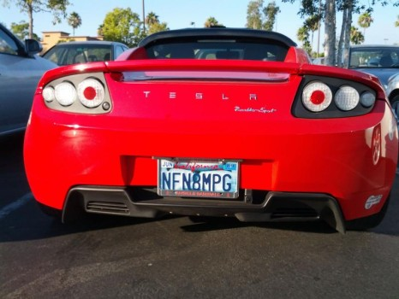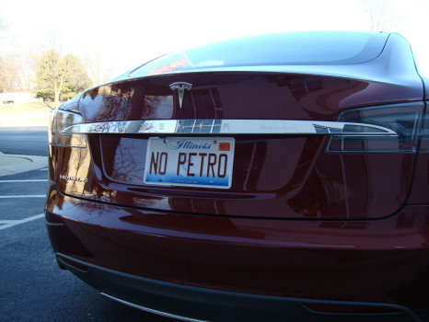
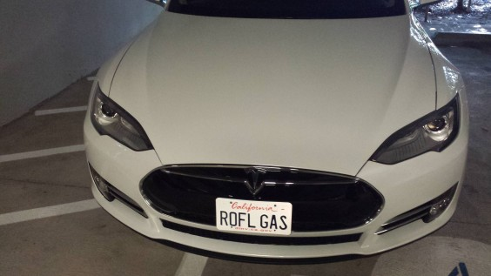
So what does a brand really sell? A promise?
No. A belief. A belief in a belief in a better tomorrow. A vastly different and better tomorrow. If it’s not vastly different and better, people won’t care. Why should they?
That’s why a brand is a belief. That’s why your brand must be a belief.
There’s one last element about a brand that you must understand: A belief is not enough. To be a brand and not a generic, your brand has to believe in a tomorrow that your competitors don’t believe in. You have to sell a tomorrow that no one else sells. That belief sets you apart, gets attention, and gets sales because the people who want the world you sell will buy from no one else because no one else sells it.
If you try to sell a tomorrow that others sell, you won’t get attention, you have a harder time closing sales, and the established brands will force you to beat them on price, which is not a contest you want to win.
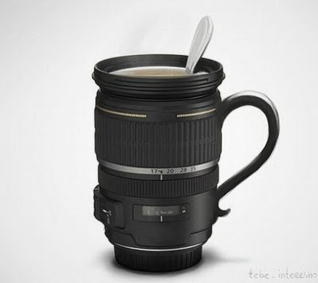
Think about if you were to try to open a coffee shop in your town. Your town probably has dozens of coffee shops already, including dozens of Starbucks and Dunkin Donuts. When you enter that market, you won’t be able to compete by selling coffee. You won’t even be able to compete selling a world of sustainably grown coffee with comfortable lounge environments and wi-fi (Starbucks), or a world of cheap, fast joe in which you dunk fat cream-filled eclairs (Dunkin Donuts). Nope, you will have to brand on a different coffee-based world. Maybe a world in which coffee is liquid sex and contains additives that (actually or suggestively) cranks people’s libidos at 6AM. Or maybe a world in which coffee is the path to spiritual transcendence and the vision of God is glimpsed through a properly imbibed mug of moccachino.
Whatever your belief is, it has to differ from your competitors’ beliefs. If it doesn’t, you are a copycat and people will go with the original.
Got all that?
Here’s the full, fully functional definition of a brand that you can put to use right now:
A brand is a belief in a better world that differs from your competitors’ worlds and is a world that your customers want to live in.
A brand is a belief in a better world that differs from your competitors’ worlds and is a world that your customers want to live in.
This definition is useful because everything you need to build a good brand is contained within it. It tells you everything you need to make more of to make more brand: To build a brand, choose a belief in better tomorrow that your competitors don’t believe in and that your customers want to live in. Believe more and the brand gets better. Believe in a tomorrow that is more different from your competitors and your brand gets better. Believe in a world that more people want to live in and your brand gets better. More belief, more different, and more people means a bigger, better brand.
And that’s exactly what you want to build as an entrepreneur because that’s how you’re going to surprise your well-established and well-healed rivals.
Now that you know what a brand is and how to build a good one, schedule a free consultation with me get some sharp, private advice about your brand today.
Share this article with anyone you know who is working under the idea that a brand is so profound that it can’t be understood because all that results in are brands that no one understands–including them. We need more meaningful brands. Not abstract ones.

