Call for Presenters- WACYCP Annual
Youth Worker Conference
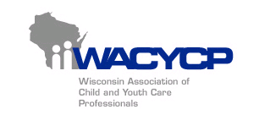
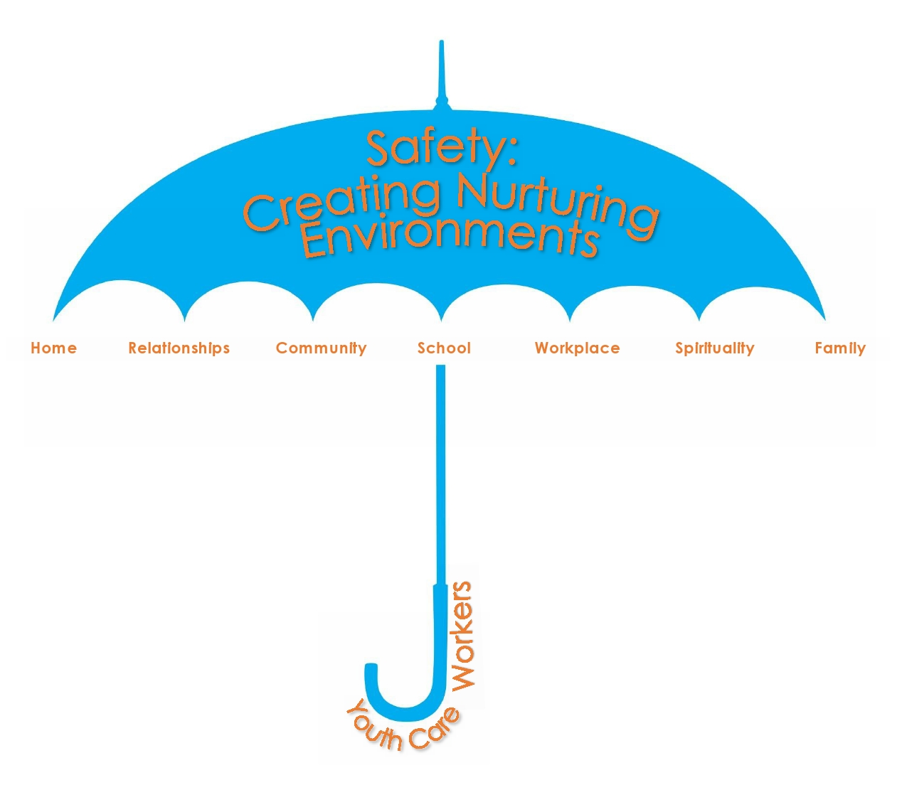
Thursday April 30th, 2015
UWM School ofg

The Wisconsin Association of Child and Youth Care Professionals (WACYCP) are accepting proposals for the 2015 WACYCP Annual Youth Care Conference. The all-day conference will be held on Thursday April 30th at the UWM Youth Work Learning Center in Milwaukee, WI. The theme of this year’s conference is “Safety: Creating Nurturing Environments”.
We are seeking proposals in many topic areas. Each workshop should be 90 minutes long. We are also offering a 30 minute Poster Session option this year. Please specify if the workshop is aimed for an introductory, intermediate or advanced direct youth care worker. Workshops should be aimed at youth care workers who work with youth aged 7 to 18. Some suggested topic areas are:

- Diversity in Youth Work Settings 13. Mandatory Reporting
- Teaching Healthy Boundaries 14. Sexual Exploitation of Youth
- Crisis Stabilization 15. Out of Home Care
- Gangs- Strength Based Approach 16. Hiring Quality Youth Care Staff
- Incarcerated Parents and/or Family Issues 17. Youth Mental Health
- Independent Living Skills 18. Youth Sexuality Issues
- Implementing Programs/Program Planning 19. Trauma Informed Care
- Resource Development/Grant Writing 20. Administrative Topics
- Seclusion/Restraint 21. Any other pertinent topic
- Gender Specific Programming in the Youth Work Setting
- Youth Led/Youth Facilitated Workshops
- Domestic Violence and Youth Work

Compensation: Each workshop that is selected will receive a complimentary admission for the all-day conference, for each conference presenter (if more than one for the workshop).
Please complete the following information and submit to the WACYCP for consideration:
- Workshop Title
- Main Presenters Name
- Main Presenters Title and Contact Information
- Other Presenters Names and Titles (if applicable)
- Mailing Address
- Email Address
- Contact Phone Number
- Preferred Presentation Format: 90 minute workshop
30 minute Poster Session
OR BOTH
- The workshop rooms can accommodate between 20-50 participants. Is there a limit to number of participants for your workshop?
- Short Description of the Workshop (may be used in conference brochure)
- How does this workshop relate to our conference theme of “Safety: Creating Nurturing Environments”?
- What National competency domain does your workshop cover? For more information on the domains, visit www.cyccb.org
Professionalism
Cultural & human diversity
Applied human development
Relationship & communication
Developmental practice methods

All proposals are due by Friday February 6th, 2015 at 5:00 pm. If you have any questions, please contact the WACYCP office at (414) 519-3130 or via email to wacycp1@sbcglobal.net

To turn in your proposal, please utilize one of the following methods:
By Email: wacycp1@sbcglobal.net (preferred method)
By Fax: (414) 562-4557 Attn: WACYCP
By US Mail:
WACYCP Attn: 2015 Conference
PO Box 510423
Milwaukee, WI 53203

