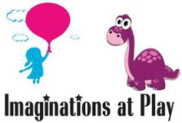

JOIN NIS OVER BREAK AT A PRIVATE PARTY:

FEBRUARY 17TH, 10 AM – 12 PM
1859 LAKELAND AVENUE, RONKONKOMA
The facility features hands-on educational experiences which incorporate sensory and dramatic play. The Imagination Village has many play areas set up to educate and entertain children of various ages. From sand and water to trains and dolls, there is something to please every child.

$12/CHILD

FILL OUT REPLY SLIP BELOW AND PUT IN A SEALED ENVELOPE WITH YOUR PAYMENT NO LATER THAN FEBRUARY 13TH.

Imaginations at Play Reply Slip

Number of Children Attending: ___________ Amount Enclosed: ___________

First & Last Name of Child(ren): __________________________________________________________________________

