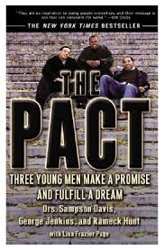


At Fullerton College, the One Book, One College program selects a book each year to promote literacy and community building across the entire campus.

Read: The Pact!
This inspirational true story takes place in New Jersey during the 1980s at the height of a crack epidemic that ravaged many communities. Three young men made a promise to each other to overcome their challenging circumstances. Find out how they did it!
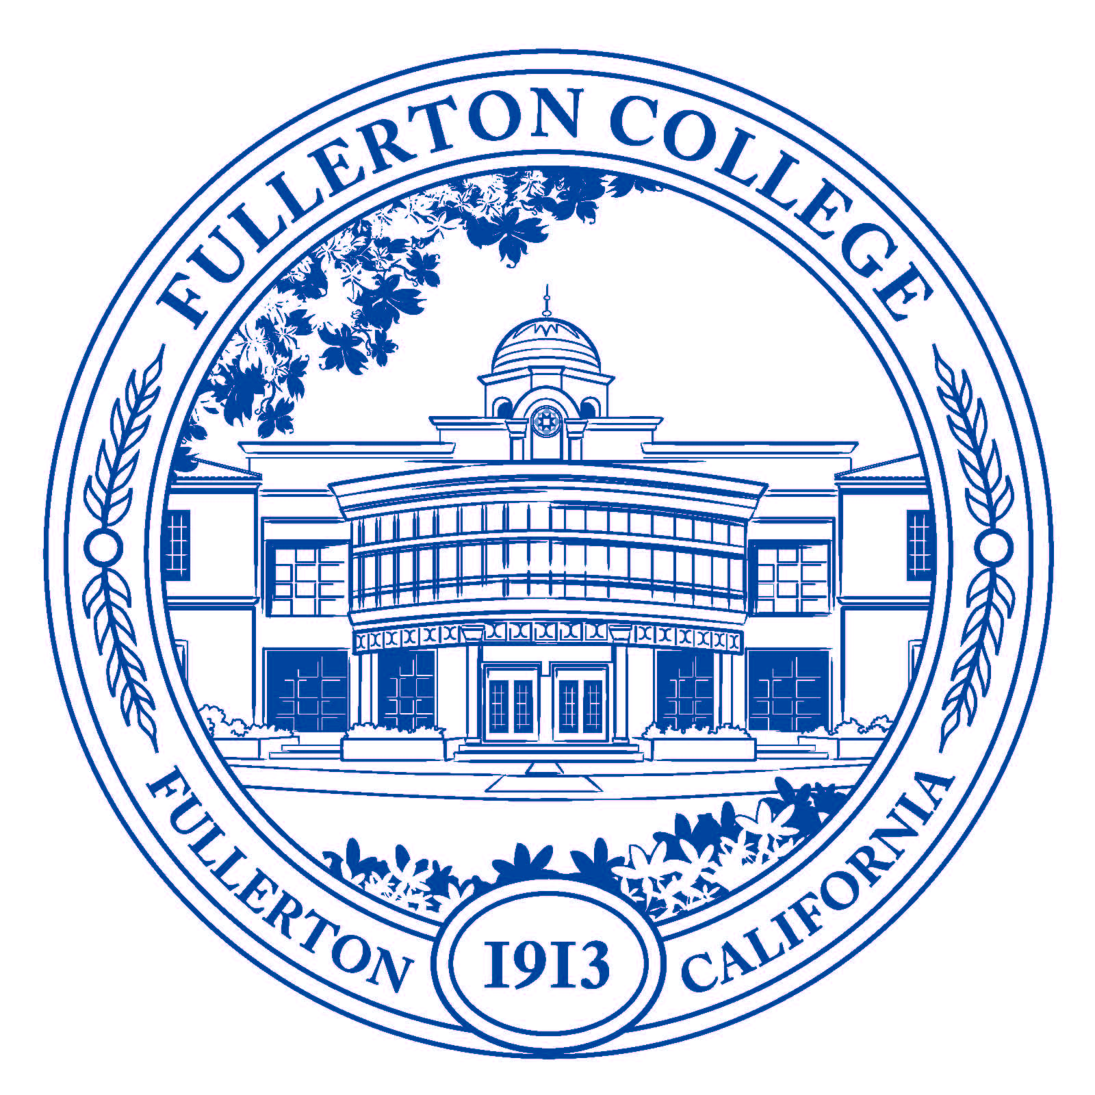

Attend: Movie Screenings

Friday, November 14: 10:15-12:30: Room 521

Monday, December 1: 12:45-2:50: Wilshire Auditorium


Available online and in bookstores everywhere.

Contact: Kim Orlijan at Fullerton College(korlijan@fullcoll.edu)

