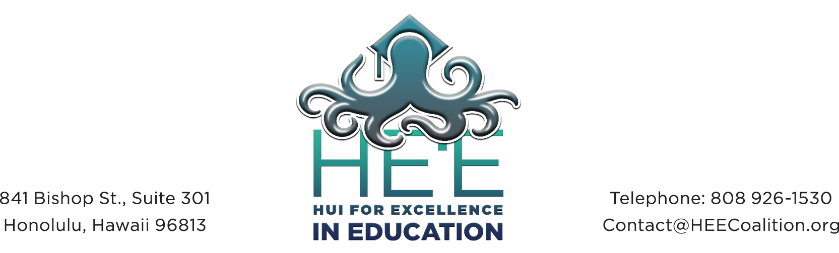

Hawaii Board of Education
Don Horner, Chair
Brian De Lima, Vice Chair

January 20, 2015

Dear Chair Horner, Vice Chair De Lima and Members:

The Hui for Excellence in Education (HE‘E) is a diverse coalition of over 40 parent and community organizations dedicated to improving student achievement by increasing family and community engagement and partnerships in our schools. Our member list is attached.

This testimony is submitted in regards to the revision of BOE Policy 2203 on the Comprehensive Student Support System. A workgroup in which HE‘E participated convened in 2014 for House Concurrent Resolution HCR 57 on Family-School Partnerships; this group recommended and submitted a revised BOE Policy 2203. A copy of the revised policy is attached. This revision recognizes the six critical elements that are part of the Department’s Continuum of Proactive Student supports and includes an array of services. HE’E believes that the policy submitted in 2015 is more current and relevant and should be considered.

Thank you for the opportunity to testify and for your consideration. Our support of this policy represents a 75% consensus or more of our membership.

Sincerely,

Cheri Nakamura
HE‘E Coalition Director

HE‘E Member List
Academy 21
After-School All-Stars Hawaii
Alliance for Place Based Learning
*Castle Complex Community Council
*Castle-Kahuku Principal and CAS
Center for Civic Education
Coalition for Children with Special Needs
*Faith Action for Community Equity
Fresh Leadership LLC
Girl Scouts Hawaii
*Good Beginnings Alliance
Harold K.L. Castle Foundation
*Hawaii Appleseed Center for Law and Economic Justice
Hawai‘i Athletic League of Scholars
*Hawai‘i Charter School Network
*Hawai‘i Nutrition and Physical Activity Coalition
*Hawaii State PTSA
Hawai‘i State Student Council
Hawai‘i State Teachers Association
Hawai‘i P-20
Hawai‘i 3Rs
Head Start Collaboration Office
It’s All About Kids
*INPEACE
Joint Venture Education Forum
Junior Achievement of Hawaii
*Kaho‘omiki
Kamehameha Schools
Kanu Hawai‘i
*Kaua‘i Ho‘okele Council
Keiki to Career Kaua‘i
Kupu A‘e
*Leaders for the Next Generation
Learning First
McREL’s Pacific Center for Changing the Odds
Our Public School
*Pacific Resources for Education and Learning
*Parents and Children Together
*Parents for Public Schools Hawai‘i
Punahou School PUEO Program
Teach for America
The Learning Coalition
US PACOM
University of Hawai‘i College of Education
YMCA of Honolulu
Voting Members (*) Voting member organizations vote on action items while individual and non-voting participants may collaborate on all efforts within the coalition. List as of January 2015

