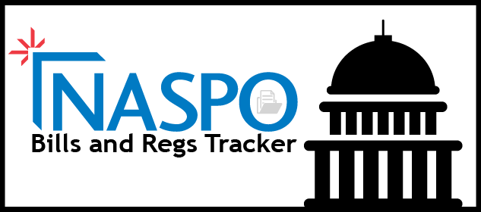

**New from NASPO! You can view the Bills and Regs Tracker on the NASPO Network** to review procurement related state and federal legislation and regulation. If you have any questions or feedback, please contact Sarah Razor at srazor@naspo.org.

**Step One: Log in to the NASPO Network.**   
Please note that you cannot send the bill tracker link to others or bookmark it for access – you must log into the NASPO Network. However, reports can be printed in hard copy or saved and shared.

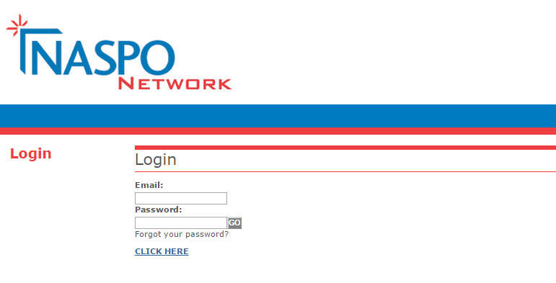

Do you have questions or suggestions on specific bills or regs NASPO should track from your state? Please contact Sarah Razor at [srazor@naspo.org](mailto:srazor@naspo.org). Identifying search criteria takes some finessing and refinement, especially at the beginning of each legislative session. We appreciate your input in this new member service.

**Step Two:** **Go to the Resources tab in the NASPO Network, then click Bills and Regs Tracker link**.   
  
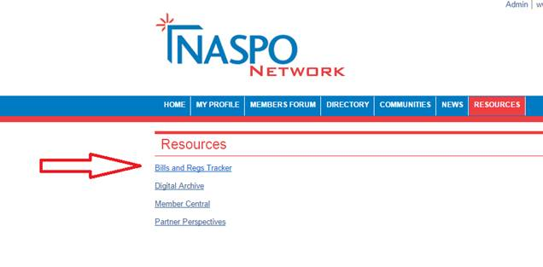

**Step Three: Use the drop down menus to begin searching**.   
After you select a topic, click on the display button to refresh the page to see which states have legislation related to your selected topic. You can click on the populated states or follow the link to “Display report for all states” to review more in depth information.

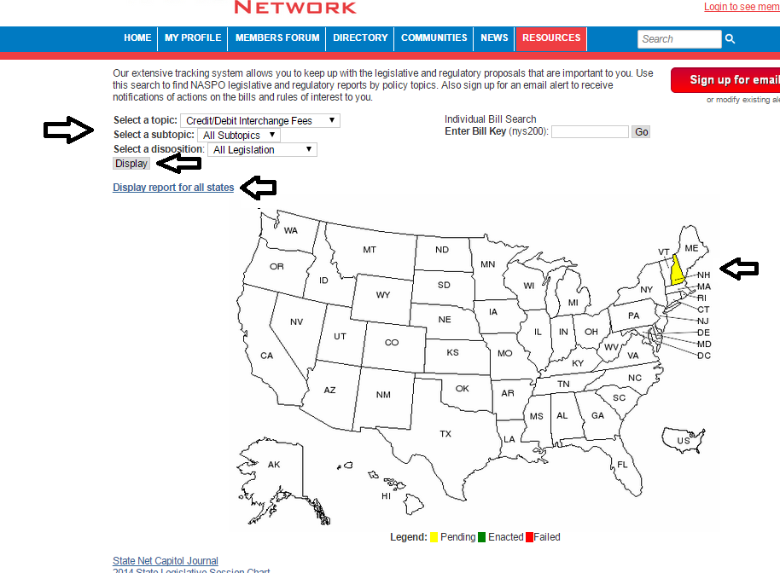

**Step Four: Read more about the bills and regs.**The report provides a basic summary, author and current status information. You can follow the link on the bill name to be directed to the original location of the bill for the most complete and timely information. Bills and regs tracker searches directly from individual state and federal sources and is refreshed on the NASPO Network each morning.   
