Webinar: Caseload to Workload and the role of Specialized Instructional Support Personnel (SISPs)

The IDEA Partnership will host a free webinar on Caseload to Workload and the role of Specialized Instructional Support Personnel (SISPs) on January 22, 2015 from 1:00-2:30 pm EST.

Speakers will include representatives from the American Occupational Therapy Association (AOTA), the American Physical Therapy Association (APTA), and the American Speech Hearing Language Association (ASHA).

The webinar will share state success stories and workload benefits to all stakeholders. Downloadable practice resources will be offered.

Instructions for Accessing the webinar
- Sign into Adobe Connect five minutes before 1:00 PM ET : https://tadnet.adobeconnect.com/_a984157034/partnership
  - Click "Enter as a Guest" and type your full name. Then click "Enter Room"
- For audio – choose one from 2 options
- Dial-out Option (recommended)
- Select the first option “Join Audio Conference” (Dial-out)
- Enter your phone number with area code (Eg. +1-415-555-1234)
- Click “Join”
- Adobe will call you shortly after.
- Using Microphone Option
- Select the third option “Using Microphone”
- Click “Join”
- Listen to the audio through your computer speakers
- You do NOT need a microphone or your telephone for this option.

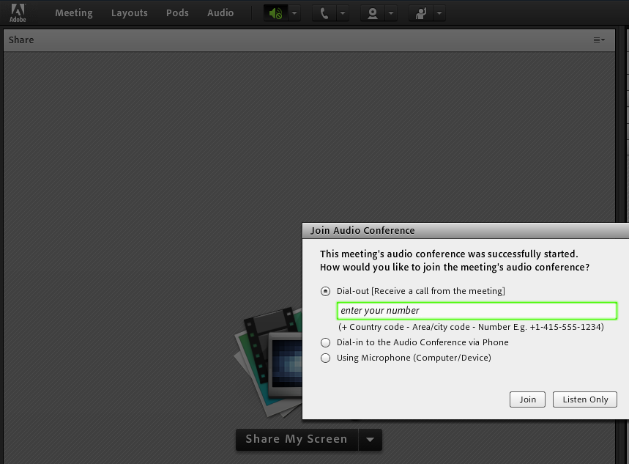
Using Microphone
Please select this option if you want to listen through your computer speakers. You will be able to participate in the webinar through the chat.
Dial –out
Please select Dial-out option to listen to the webinar via telephone. Type your phone number with area code Eg. +1-415-555-1234 and click Join

- All lines will be muted during the webinar.
- If you have a question during the webinar, please type your question into the chat box on the right side.

First Time Adobe Connect Attendees – check your computer before the webinar …
- Please make sure you have prepared your computer to access the meeting through Adobe Connect
- If you have never attended an Adobe Connect meeting before please test your connection by going to https://tadnet.adobeconnect.com/common/help/en/support/meeting_test.htm
- To get a quick overview of Adobe connect go to: http://www.adobe.com/go/connectpro_overview
- If you have any questions before the webinar please contact Sandy Schefkind

