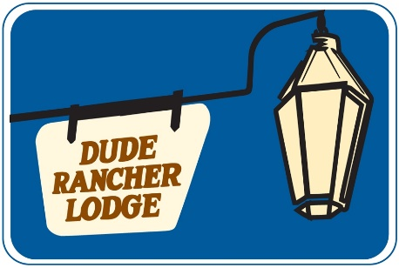
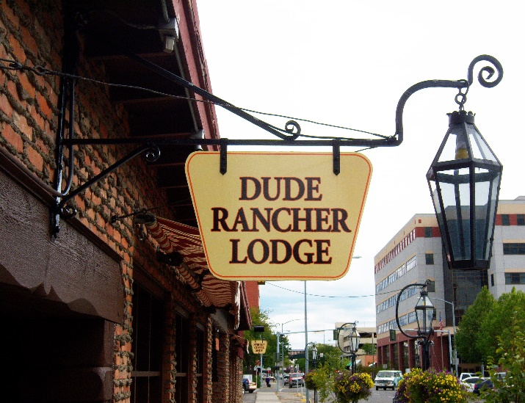

Reduced Rate Exclusively

for the MATE Show

Use Code MATE
FREE
• Hi Def Cable

• Wifi 30mb

• Abundant Parking

• Onsite Cafe

• In-Room Coffee Makers

• Microwaves & Refrigerators

• 3 minute drive from Metra Park

Dude Rancher Lodge
415 N 29th St.
Billings, MT 59101
406-259-5561
1-800-221-3302
www.duderancherlodge.com

Experience our Western Hospitality

Our relaxed Western atmosphere has made the
Dude Rancher Lodge a Billings landmark. Our excellent restaurant, unique room décor, and friendly service will make your stay one you will always remember.

$75 Single or Double Occupancy (includes one made to order breakfast per reservation)

